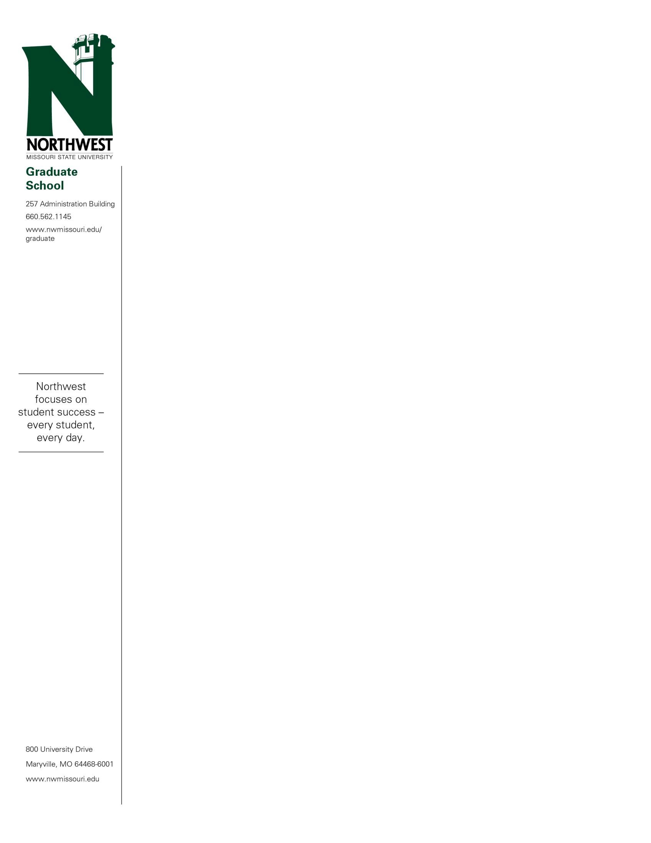

June 8, 2022

«FIRSTNAME» «LASTNAME»

«STREET».

«CITY», «STATE» «ZIP»

Dear «FIRSTNAME»:

Congratulations! You have been accepted conditionally into the Northwest Missouri State University Online Professional Master of Business Administration: Human Resource Management program beginning in the «TERM» semester.

Conditional admission, as stated in the current Graduate Catalog states “The student must achieve a 3.00 GPA in his or her first eight semester hours of graduate study or be subject to suspension for one calendar year.”

Once you are registered for your first semester, you will have access to the Online MBA eLounge through Canvas. In the eLounge you will find all the information concerning the MBA requirements and your proposed schedule. **«ADVISOR»** serves as your academic advisor in the MBA program. Her email is «ADVISOREMAIL».

You must successfully complete 54-201: MBA Business Foundations prior to taking any graduate business courses. This prerequisite is 3-credit hours and is designed to better prepare students who do not have an undergraduate degree in business.

Please review this letter carefully and contact the Graduate Office at 660- 562-1144 with any questions or concerns.

All coursework submitted to fulfill a master degree must be completed within an eight-year time period.

Northwest Missouri State University is proud of a long tradition of academic excellence, a fine faculty and a strong academic curriculum. We are happy for the opportunity to help you meet your educational goals.

Sincerely,



Gregory Haddock

Associate Provost of Graduate and Professional Studies